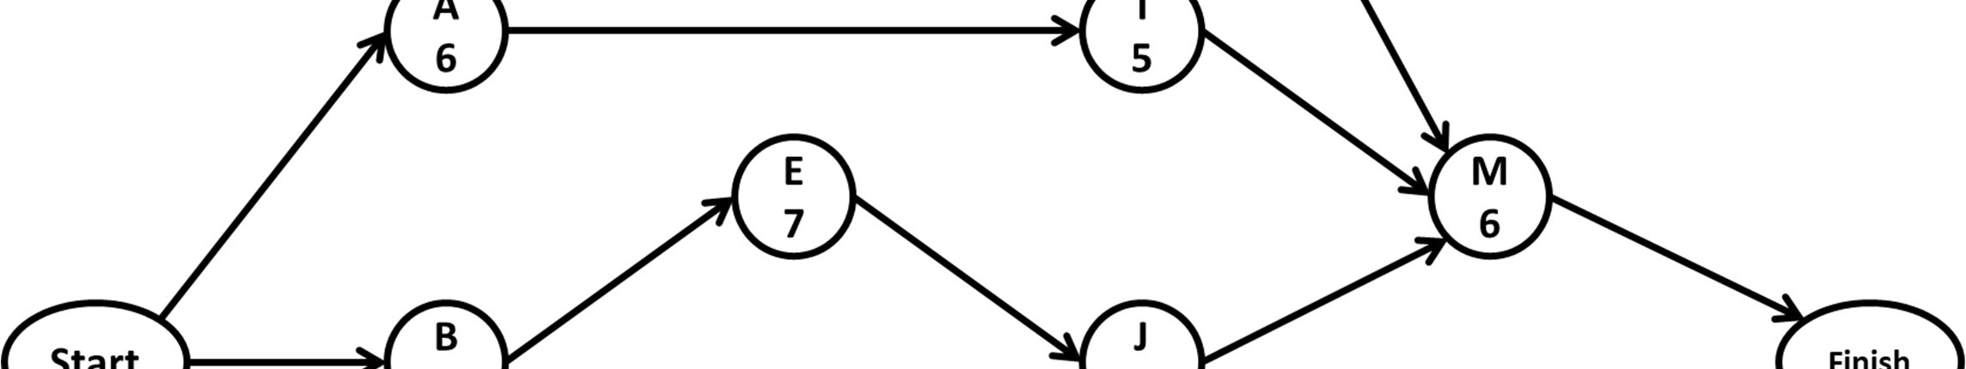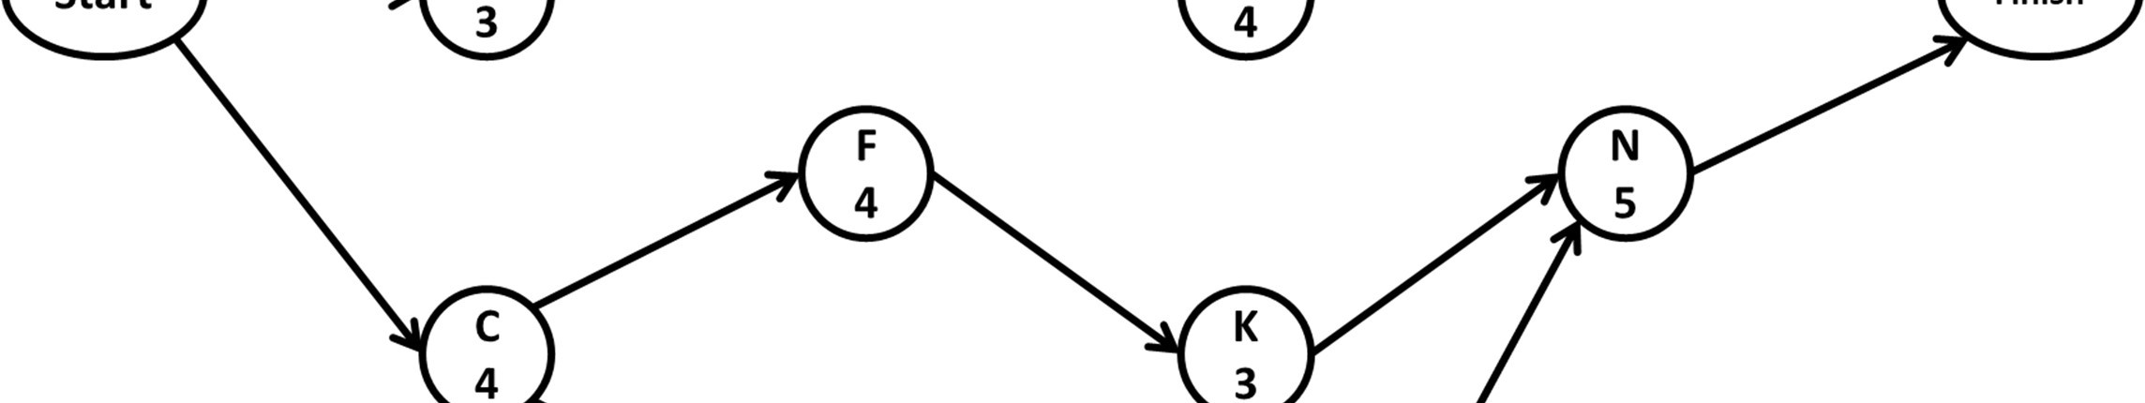
Problem 1:

ACT | ES | EF | LS | LF | TF | FF | INTF | INDF
A | 0 | 6 | 1 | 7
B | 0 | 3 | 0 | 3
C | 0 | 4 | 0 | 4
D | 6 | 10 | 7 | 11
E | 3 | 10 | 3 | 10
F | 4 | 8 | 8 | 12
G | 4 | 10 | 4 | 10
H | 10 | 13 | 11 | 14
I | 6 | 11 | 9 | 14
J | 10 | 14 | 10 | 14
K | 8 | 11 | 12 | 15
L | 10 | 15 | 10 | 15
M | 14 | 20 | 14 | 20
N | 15 | 20 | 15 | 20

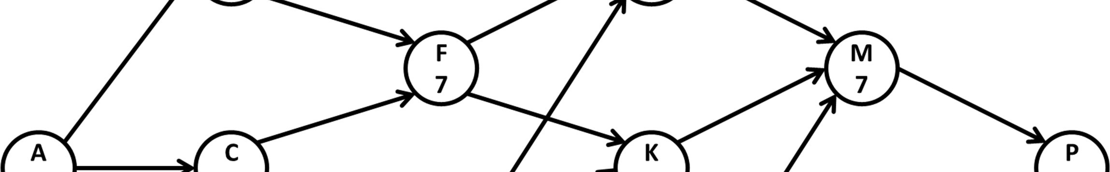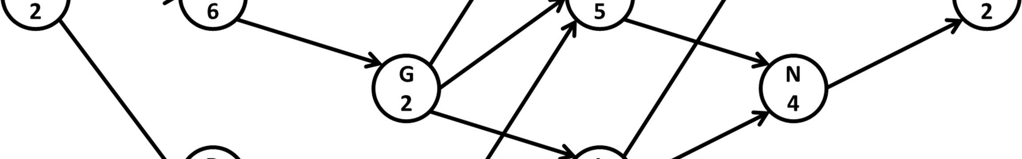
Problem 2:

ACT ES EF FF TF INTF INDF  A  B  C  D  E  F  G  H  J  K  L  M  N  P | ACT Pred LAG  A -  B A  C A  D A  E B  F B  C  G C  H D  J E  F  G  K F  G  H  L G  H  M J  K  L  N K  L  P M  N

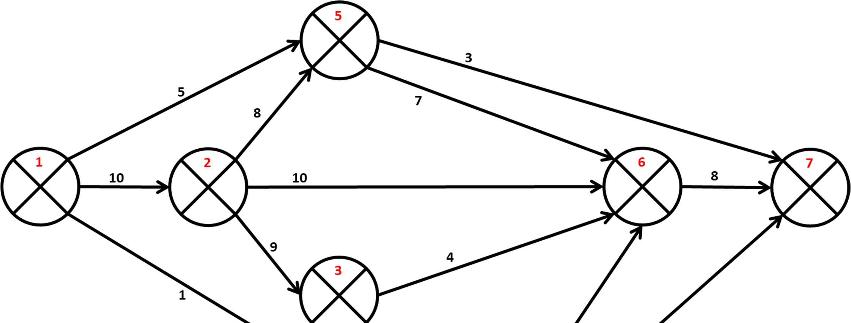
Problem 3.a:

I | J | ES | EF | LS | LF | TF | FF | INTF | INDF
1 | 2
1 | 4
1 | 5
2 | 3
2 | 5
2 | 6
3 | 4
3 | 6
4 | 6
4 | 7
5 | 6
5 | 7
6 | 7

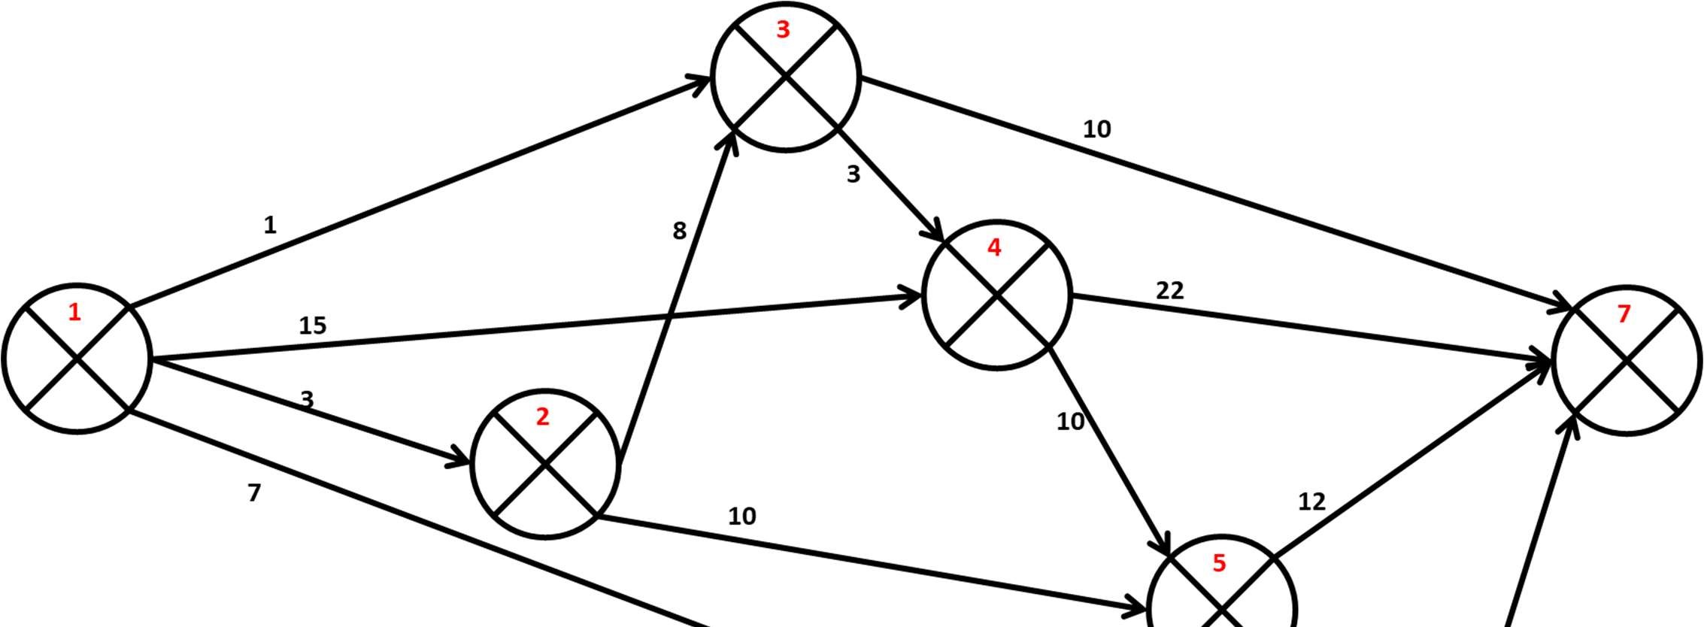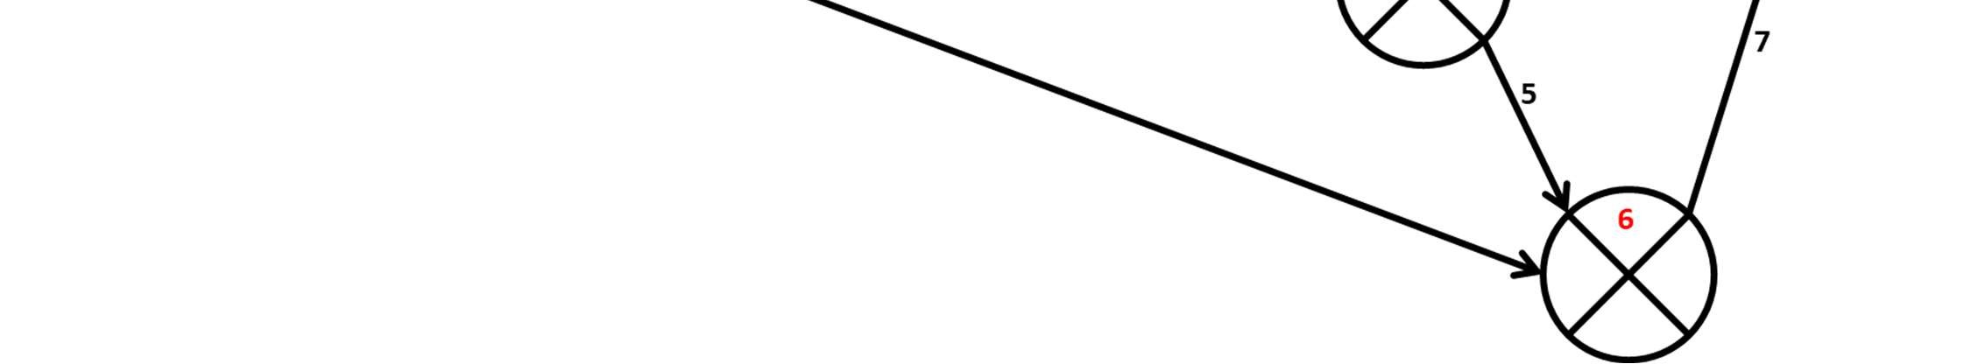
Problem 3.b:

I | J | ES | EF | LS | LF | TF | FF | INTF | INDF
1 | 2
1 | 3
1 | 4
1 | 6
2 | 3
2 | 5
3 | 4
3 | 7
4 | 5
4 | 7
5 | 6
5 | 7
6 | 7

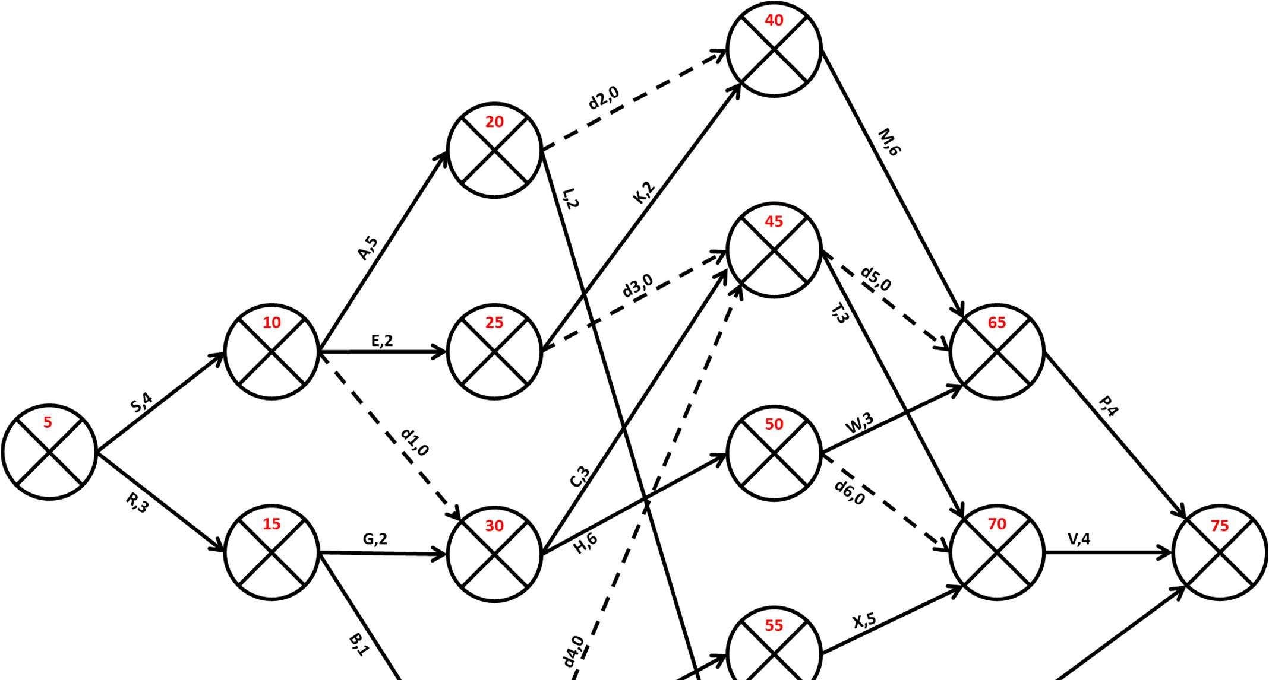
Problem 4:

I | J | ES | EF | LS | LF | TF | FF | INTF | INDF
5 | 10
5 | 15
10 | 20
10 | 25
10 | 30
15 | 30
15 | 35
20 | 40
20 | 60
25 | 40
25 | 45
30 | 45
30 | 50
35 | 45
35 | 55
40 | 65
45 | 65
45 | 70
50 | 65
50 | 70
55 | 70
60 | 75
65 | 75
70 | 75

